Sean Park

15112: Section P

November 24th, 2015

**Term Project Proposal**

Although there are many programs in the market that loop audio, most of them are geared towards professionals with extensive experience in working with sound. It is currently difficult to find a program made for the PC that is free and user-friendly. NoobLoop is a simplified version of the audio looper which only includes the essential elements of the audio looper that anyone can use without difficulty.

**Competitive Analysis**

*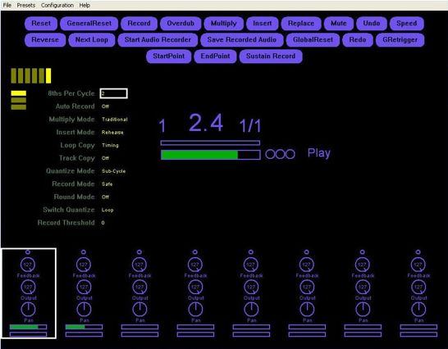Mobius & Giada*

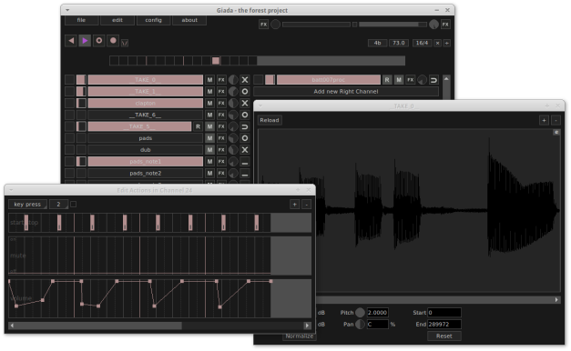

\

Mobius and Giada are currently two of the most popular free audio looping programs. They both allow the user to customize audio files in a variety of ways: changing volumes at different points in a track, changing and bending pitch, adding sound effects, overdubbing, reversing, bounce recording, etc. However, many of these modifications are unnecessary for the everyday user. The excess of functions also leads to a messy GUI. If the user has no prior experience in working with mixing audio, these programs are difficult to use.

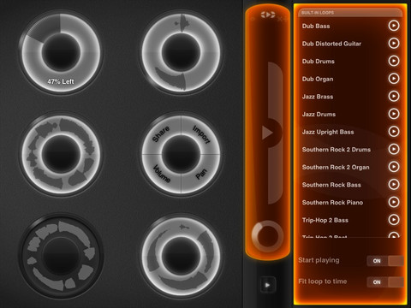*Loopy HD*

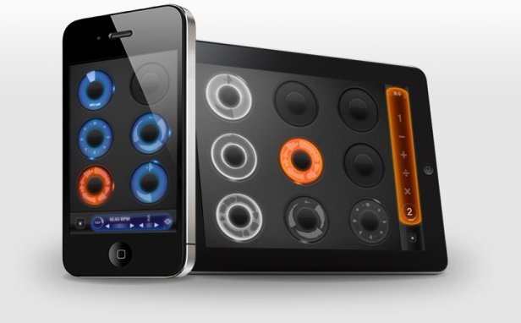

Loopy HD is a better example of a user-friendly looping application. The iOS mobile application has an attractive and intuitive user interface. It also offers the barebones functions like changing volume, pre-recorded loops, importing and exporting.

**Storyboard**

The program I intend to write, NoobLoop, will resemble Loopy HD more than Mobius or Giada. It will have a minimalistic, intuitive user interface, and the user will be able to record, loop, merge, import and export .wav type tracks. If possible, I will also allow users to select from a choice of popular sound effects and change pitch.

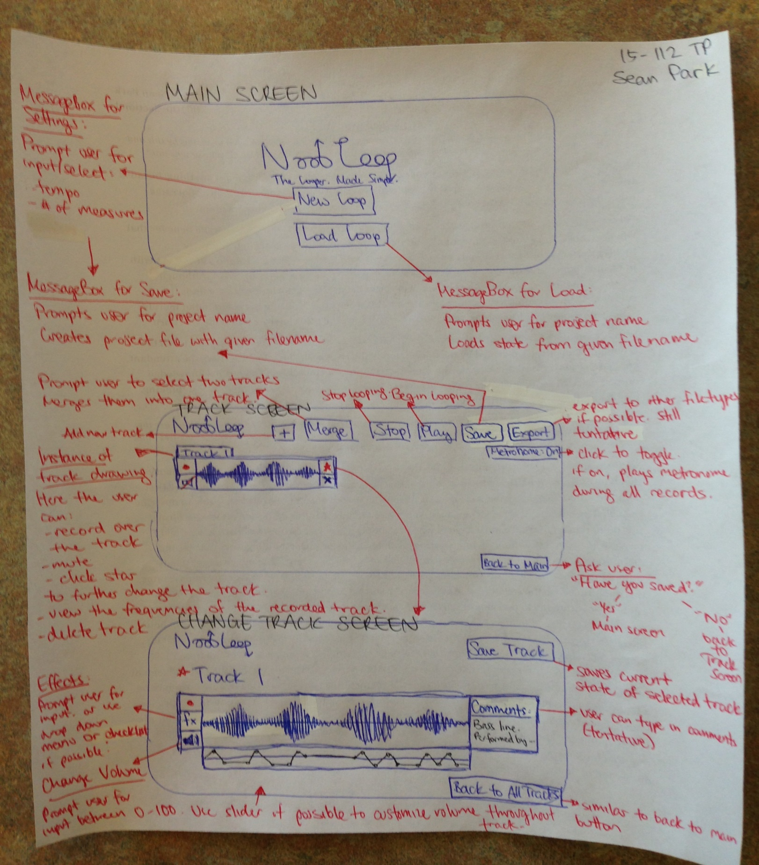The following is depiction of how the program will look to the user:

**Intended Functions & Required Technologies**

-Pyaudio will be used to access audio inputs and collect them in a stream of byte data.

-The byte data will then be written into a .wav file using the wave module.

-The wave module will be accessed by the pygame module to play and loop.

-All animation elements such as buttons and slides will be represented using the tkinter module.

-All other elements of the term project, such as adding sound effects, should be achievable using built-in functions in Python.